Lincoln High School 2025 

Summer Co-Ed Basketball Camp

For ages 5-16, all skill levels welcome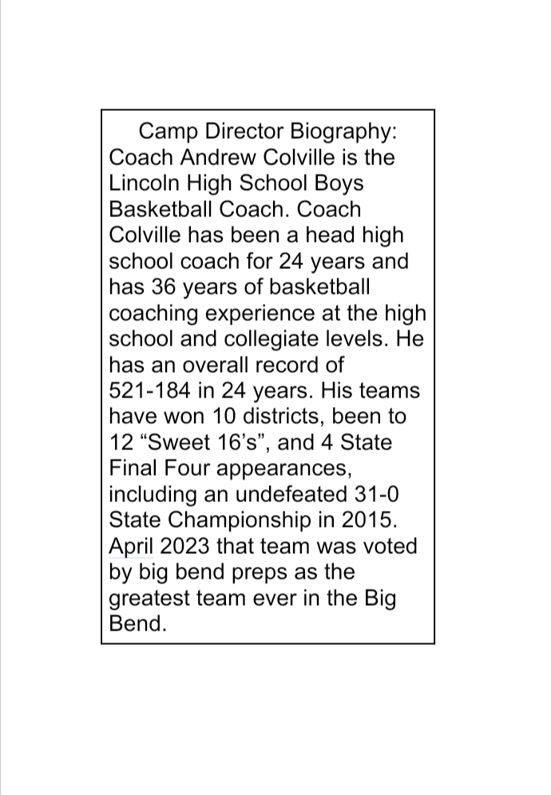

**Session 1: May 27-30**

**Session 2: June 2-6**

**Session 3: June 9-13**

**Contact: Coach Andrew Colville**

**Address: Lincoln High School**

**3838 Trojan Way**

**Tallahassee, FL 32311**

**Phone: (850) 728-9820**

**Email: colvillea@leonschools.net**

**Camp Info:**

* **Multiple children & week discounts**
* **Campers must provide their own lunch**
* **Concessions will be available daily**
* **No valuables allowed at camp**
* **Session times 9a-3p M-TH, 9a-12p Fri**
* **Free supervision 7:30a-9:00am**
* **$125 Per Session, Early registration special**
  + **$100 if paid by May 15!!**



**Make checks/money orders payable**

**To: Leon County Schools**

**Bring payment to: Lincoln High School**

**c/o Coach Andrew Colville,**

**3838 Trojan Trail**

**Tallahassee, FL 32311**

Lincoln High School 2025 

Summer Co-Ed Basketball Camp

**REGISTRATION FORM**

**Student’s Name: ____________________________ Date of Birth: ______________**

**Parent/Guardian Name: ________________________________________**

**Phone (W): ___________________ Phone (C): _____________________**

**Email Address: _______________________________________________**

**Home Address: ______________________________________________**

**Circle Session(s) Attending:**

**Session 1: May 27- 30 Session 2: June 2-6**

**Session 3: June 9-13**

**Pick Up & Emergency Information:**

**Name: _____________________ Relationship: _________________Phone:__________________**

**Name: _____________________ Relationship: _________________Phone:__________________  
List any medications, allergies, or limitations requiring special attention: __________________**

**________________________________________________________________________________**

**Liability & Photo/Video Release:**

**I am responsible for my child’s insurance in case of injury. Furthermore, I understand that although safety precautions will be observed, Lincoln High School and Leon County Schools will not be responsible for any personal property lost by me/my child or any injury sustained in the program. I also consent Lincoln High School’s use of any photographs and/or videos made of this program.**

**Parent/Guardian Signature: _______________________________________________Date: ____________**